STORE THE EXECUTION REPORT AT YOUR LOCAL SYSTEM OR PROJECT FOLDER

1. Update your playwright.config.ts file with the following code:
2. It will create a new folders under the project folder in the name of jsonReport to store the json file and playwright-report to store the index.html file
3. reporter:[['dot'], ['json',{
4. outputFile: "jsonReports/jsonReport.json"
5. }], ['html',{
6. open:'never'
7. }]],
9. 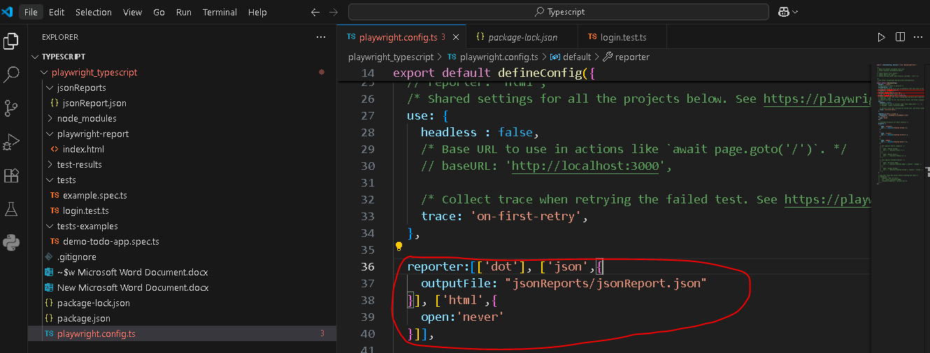

If you want the screenshot and vidoes then you need add the following lines in you playwright.config.ts file

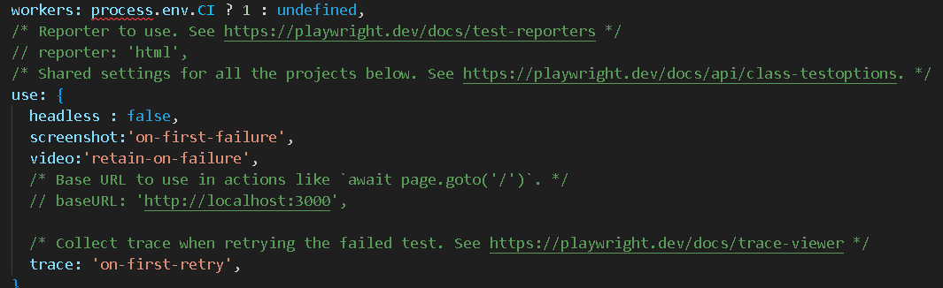

Install following package to format the date  
npm install moment --save